Eric Hanken
Lab Report: Experiment 26
Professor Perciballi

Introduction- The purpose of this experiment is to first synthesize potassium ferric oxalate, then test its purity and composition through titration and light absorbance tests.

Procedure- The synthesis of potassium ferric oxalate will be carried out in two separate
steps. First, ferrous oxalate will be synthesized:

Fe(NH₃)₂(SO₄)2H₂O + H₂C₂O₄ → FeC₂O₄ 2H₂O + 2(NH₄)HSO₄ + 4H₂O

To do this, add 5g of Ferrous Ammonium Sulfate to 15mL of water in an Erlenmeyer flask, then add 5 drops of H₂SO₄ and mix until the solid is dissolved. Once this is complete, add 25mL of 1M oxalic acid. Slowly, heat this solution to a boil. After it has boiled, remove the heat and let the solid yellow substance settle to the bottom. Carefully pour the liquid into a beaker, taking care to leave the solid yellow compound in the flask. Add 20mL of DI (DeIonized) water to the flask. Reheat as before, but to not boil, and again pour the liquid out while making sure to leave the solid in the flask. At this point, there should only be the yellow solid in the flask (a small amount of liquid is okay). Add 10mL of a saturated potassium oxalate solution. The next few steps should be done separately on the side. Obtain 20mL of 3% H₂O₂ in a beaker and 8mL of 1M H₂C₂O₄ in a graduated cylinder, and set up a filtration with a 250mL flask. After this is set up, heat the yellow solid solution to 40 degrees Celsius. You should stop heating at around 25-30 degrees because the thermometer will continue to rise after the heat is removed. After the heat is removed, add the previously prepared 20mL of 3% H₂O₂ VERY slowly. To insure the 20mL are added slowly enough, fill a pipette and do it drop by drop. Yes, this takes a long time. As the H₂O₂ is added the yellow solution should turn to a dark brown/black color. After all 20mL have been added. Reheat the solution to a boil. As it is boiling, add 5mL of the previously prepared 1M H₂C₂O₄ all in one shot. Then slowly pour the rest in. The solution turns from an opaque dark brown to a clear neon green color. Remove heat, and stir thoroughly. Pour this through the filter you have set up. Allow the solution to cool to room temperature and then transfer it to a 150mL beaker. Add 10mL of ethyl alcohol and mix. Place this solution in a dark place and allow to sit for about a week.

After returning in a week’s time, there should be green crystals in the bottom of the beaker. Set up a filter and filter the green crystals from the liquid. Use a wash bottle and DI water to get all the crystals from the bottom. Wash the crystals with a 50/50 water to ethyl alcohol mix. Put the crystals on a dry piece of filter paper and bolt them with another piece of filter paper until they are totally dry. Weigh them and add them to a vial with proper labeling. Measure out 1g of the crystals and put them into a 100mL volumetric flask. Add to the flask about 50mL of DI water and mix until the solid is dissolved. If the solid is not totally dissolved after excessive mixing it is acceptable to add SMALL amounts (3-5mL’s at a time) of DI water until the solid dissolves. Once there is no more solid visible, add 20mL of 3M H₂SO₄ and then add DI water up to the fill line on the flask (it should be around 20-30mL depending on if water was added to assist the dissolving process). Place the stopper in the top of the flask and invert it 20 times to insure sufficient mixing. Pour this into a DRY 250mL Erlenmeyer flask. Ensure that the flask is totally dry, as any water will change the concentration of the solution. Label this flask “A”. Clean out the volumetric flask with DI water. Using a 5mL transfer pipette, take 5mL of solution A and put it in the volumetric flask. Fill the flask up to the fill line with DI water, and invert it 20 times with the stopper in place to mix it. Label this solution “B”. Using the transfer pipette, place 5mL of solution B into another 100mL volumetric flask. Add 10mL of 1M sodium acetate, 2mL of 10% hydroxylamine hydrochloride, and then 3mL of 0.25% 1,10-phenanthroline. Mix well. Let the solution sit for 5 minuets, then fill the flask to the mark with DI water.
Next, place the prepared “Standard Complex Solutions” in the spectrophotometer. After recording their absorbance, place the solution you just prepared into the spectrophotometer to be analyzed. After all the values have been recorded, solution B can be discarded.

Next, take 50 mL of .1M potassium permanganate and put it in a 400mL beaker. Add to that 200mL of DI water. This makes a .02M solution of potassium permanganate. Mix this very well. Weigh 1.58g of oxalic acid into a clean, dry 250mL volumetric flask. Add 100mL of DI water and mix to dissolve the solid. Once dissolved, fill the rest of the flask with DI water to the fill line. Invert 20 times with stopper in place. Next, use a 20mL transfer pipette and place 20mLs of the oxalic acid solution into a clean 250mL Erlenmeyer flask. To this, add 10mL of DI water and 15mL of 3M sulfuric acid. Heat this solution until it is close to boiling (about 80 degrees Celsius). Remove the heat and titrate with the potassium permanganate. Repeat this titration two more times for a total of three trials. After completed, substitute the solution A for the oxalic acid. Still add the sulfuric acid as before and heat as before. Repeat this titration two more times for a total of three trials. After all data has been recorded. All solutions can be discarded appropriately.

Calculations:
Spectrophotometer Results 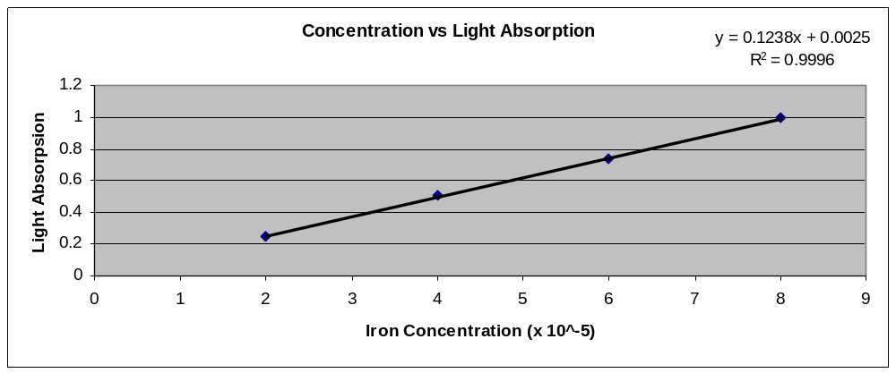
2 x 10⁻⁵ | 0.247
x | 0.424
4 x 10⁻⁵ | 0.506
6 x 10⁻⁵ | 0.738
8 x 10⁻⁵ | 0.995
y = 0.1238x + 0.0025
0.424 = 0.1238x+ 0.0025
x = 3.4 x 10⁻⁵

Because the iron was diluted twice, multiply the concentration by 2 to get the actual morality of the initial solution. 3.4 x 10⁻⁵ x 2 = 6.8 x 10⁻⁵

6.8 x 10⁻⁵ x 100mL = .0068 moles of Iron
55.845 = atomic weight of Fe
55.845 x .0068 = .387g
.387g / 1g x 100= 38.7%

Titration Results

For oxalate | For Solution A
21.91 | 26.31
22.01 | 26.09
22.00 | 26.11
AVE | AVE
21.97 | 26.17

.05M x .020L = 0.001 Moles of oxalate
5.6 x 10⁻³ moles / .02197 = .254M KMnO₄

.254M KMnO₄ x .02617L = 0.006647moles of KMnO₄
1.4 x 10⁻² moles / .020L = 0.00028M oxalate

0.00028M oxalate x .100L = 0.000028Moles of oxalate
0.000028Moles of oxalate x 88g/mole = 0.002464g of oxalate
(0.002464g of oxalate / 1.58g) x 100 = .39% oxalate

Discussion:
The quality of the results in this lab are very much dependent on the person performing the experiments. There is a lot of measuring, cleaning, and drying that must be carried out with the greatest of detail in order to ensure accurate, precise, and consistent results. The purpose of this lab was achieved using skills developed throughout the year and also relied on understanding new skills, such as operating the spectrophotometer.

